redesign web

Bumiperkasainternasional.com

REDESIGNED BY MARIO PRASETIO FOR

PT BUMI PERKASA INTERNASIONAL

Before after website

1. **Homepage**
   1. **Header**

From:

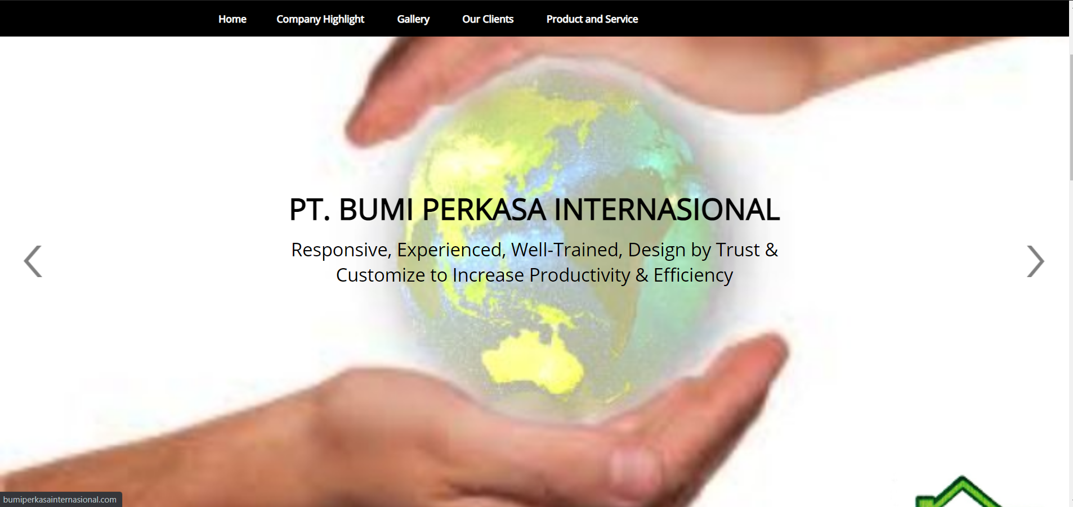

To:

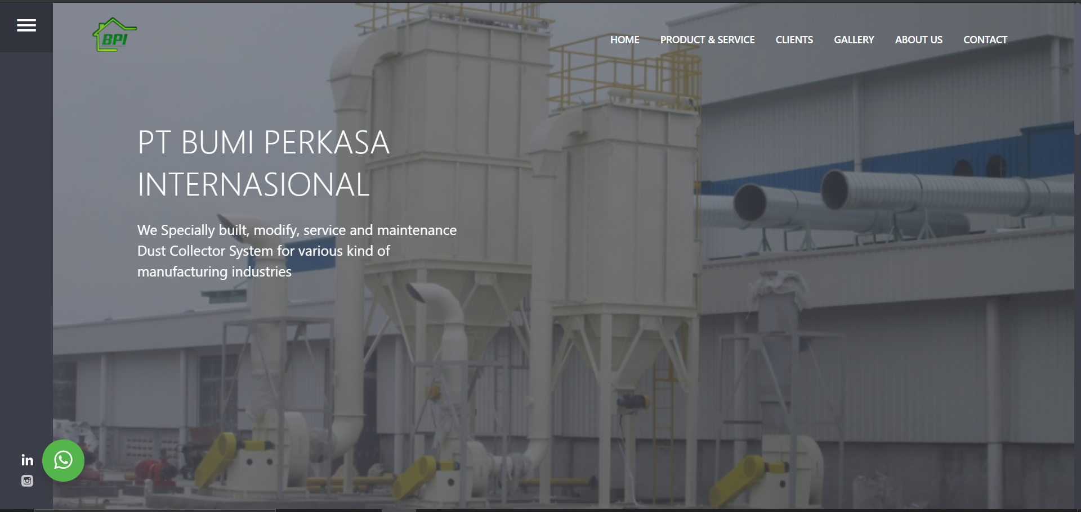

Note: Penambahan Social Media Linkedin dan Instagram, serta integrasi dengan redirect whatsapp

B. Company overview

From:

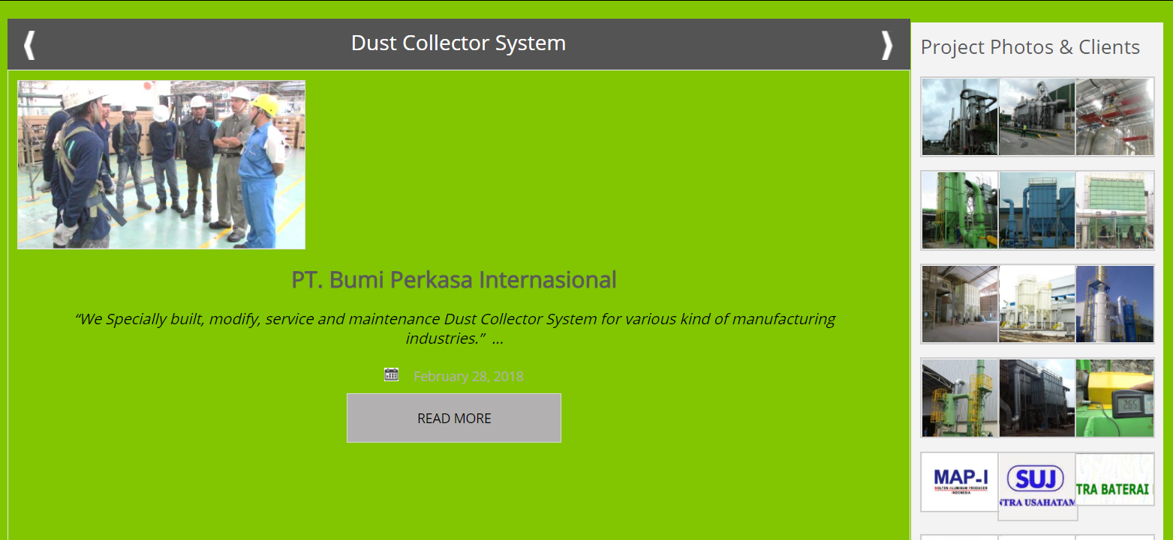

To:

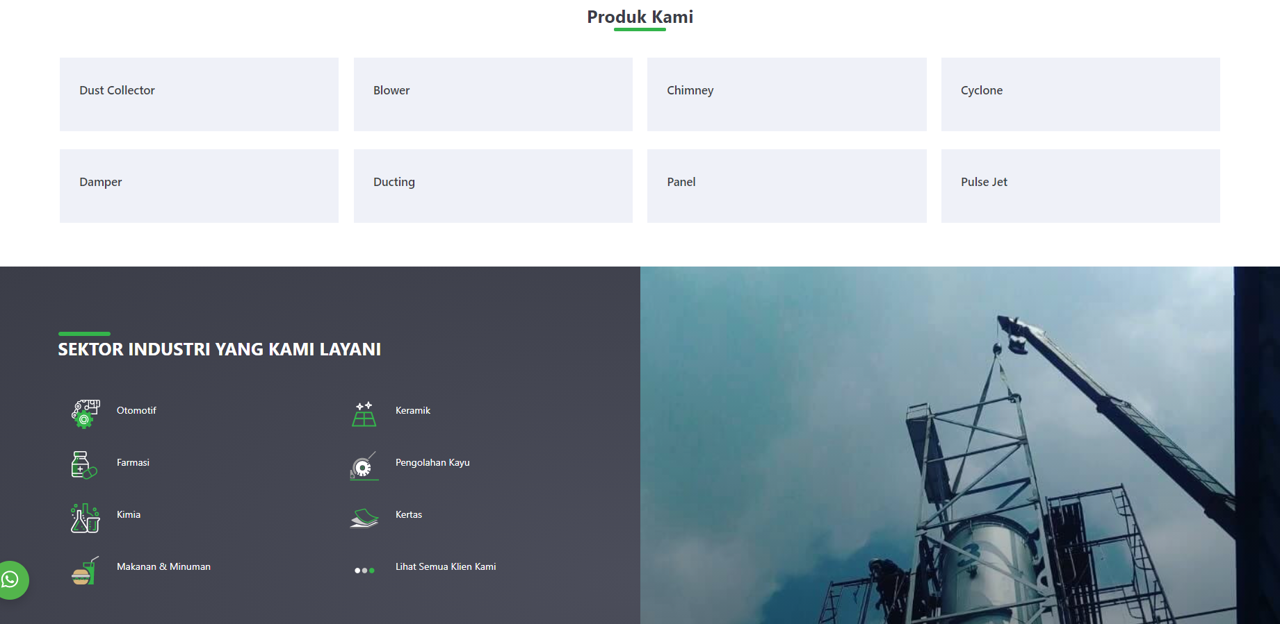

C. Penambahan LIST Client pada homepage

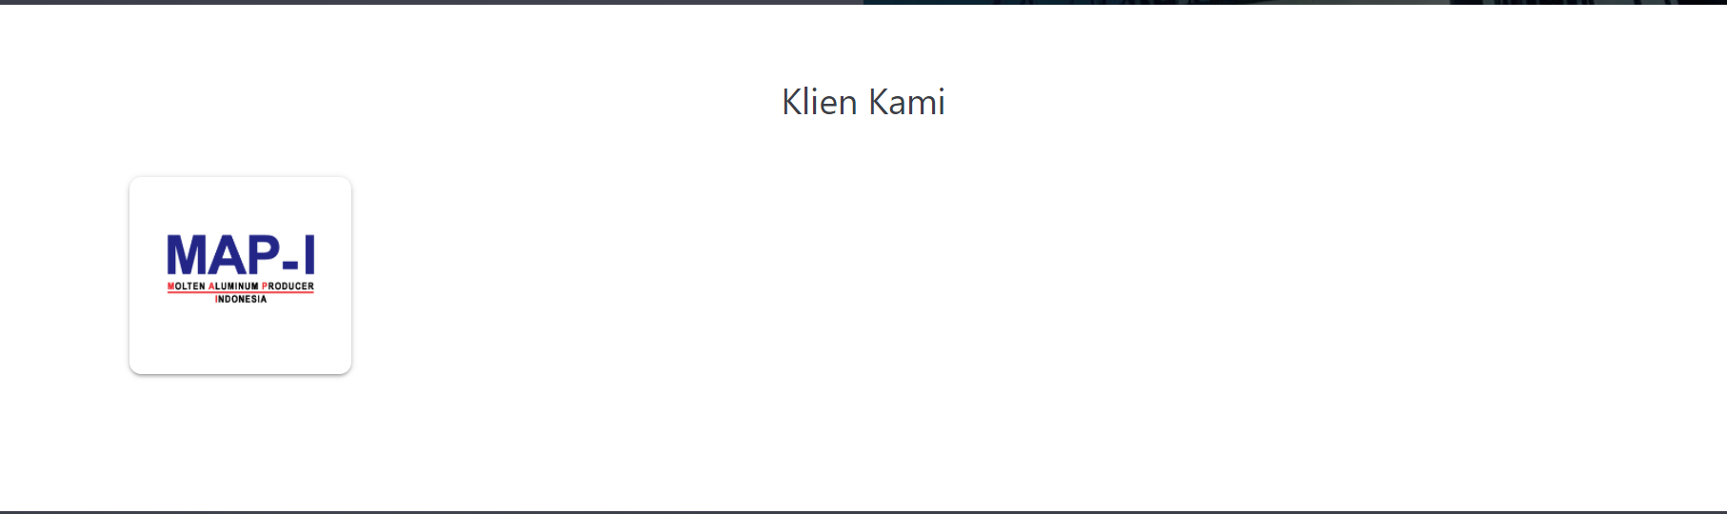

D. Redesign section contact us

From:

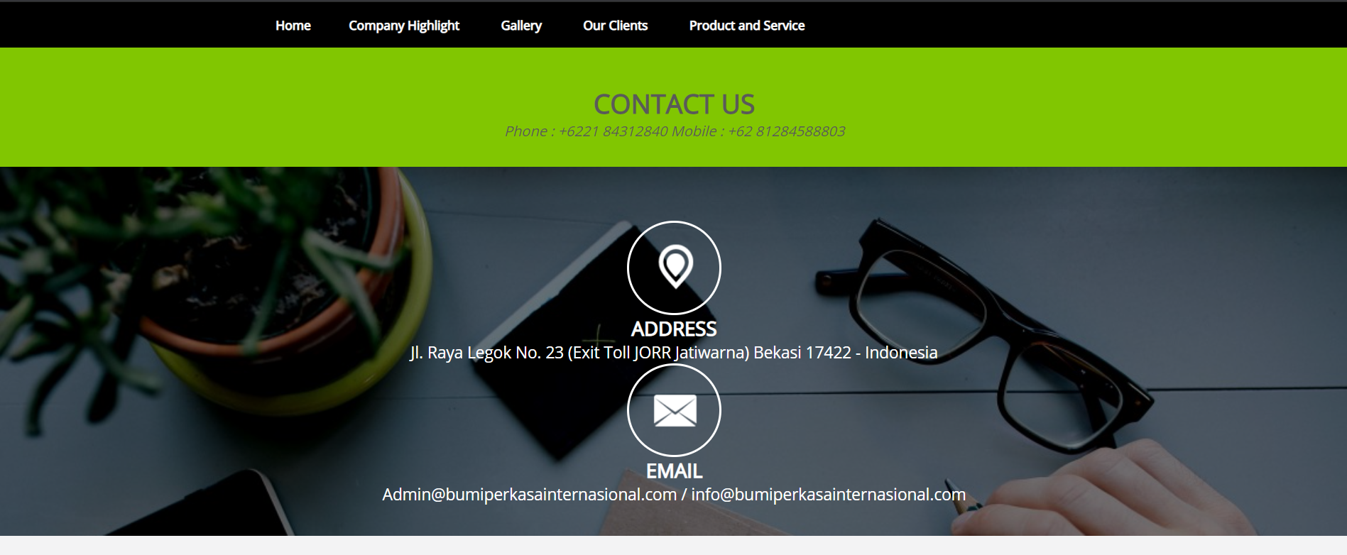

To:

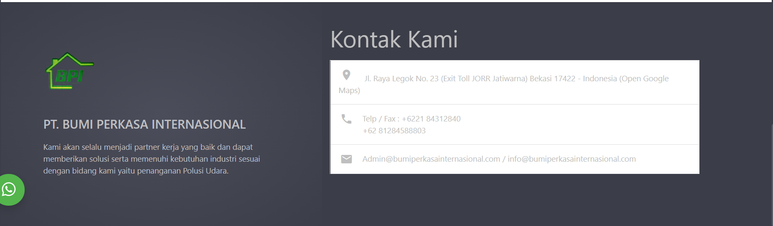

1. **Produk & Service**

Redesign halaman dari:

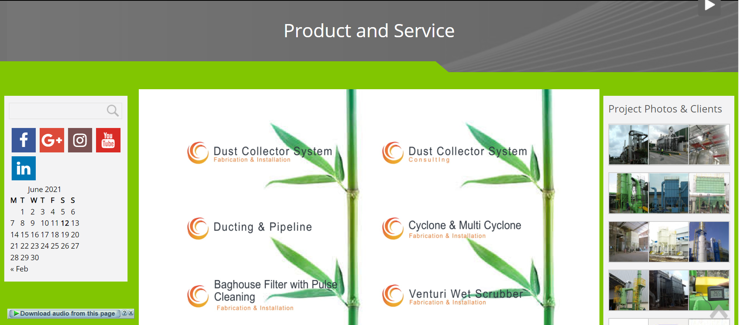

Menjadi:

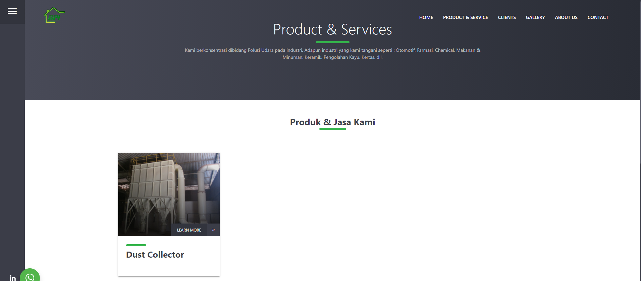

1. **Clients**

Redesign halaman

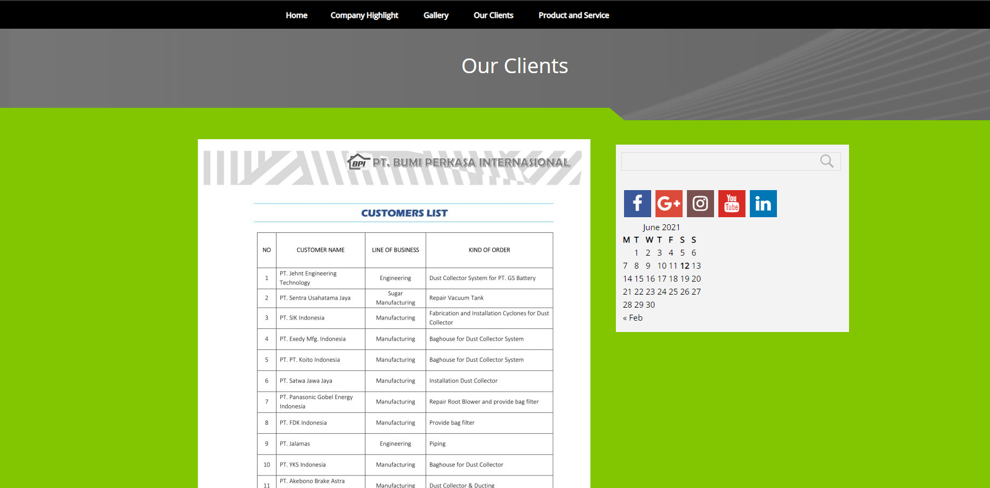

Menjadi

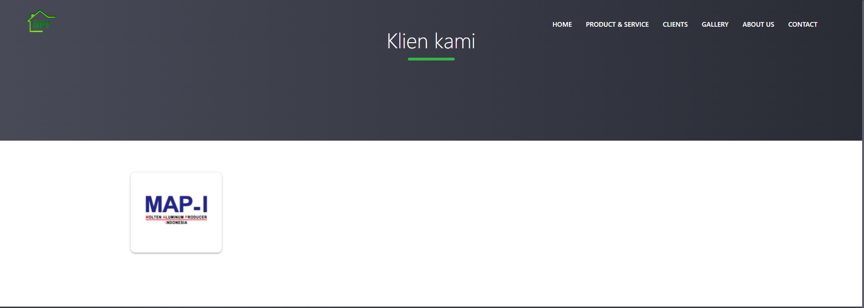

Penambahan TOP 6 Client/partner pada setiap halaman



Penambahan detil Client ketika tombol client di klik

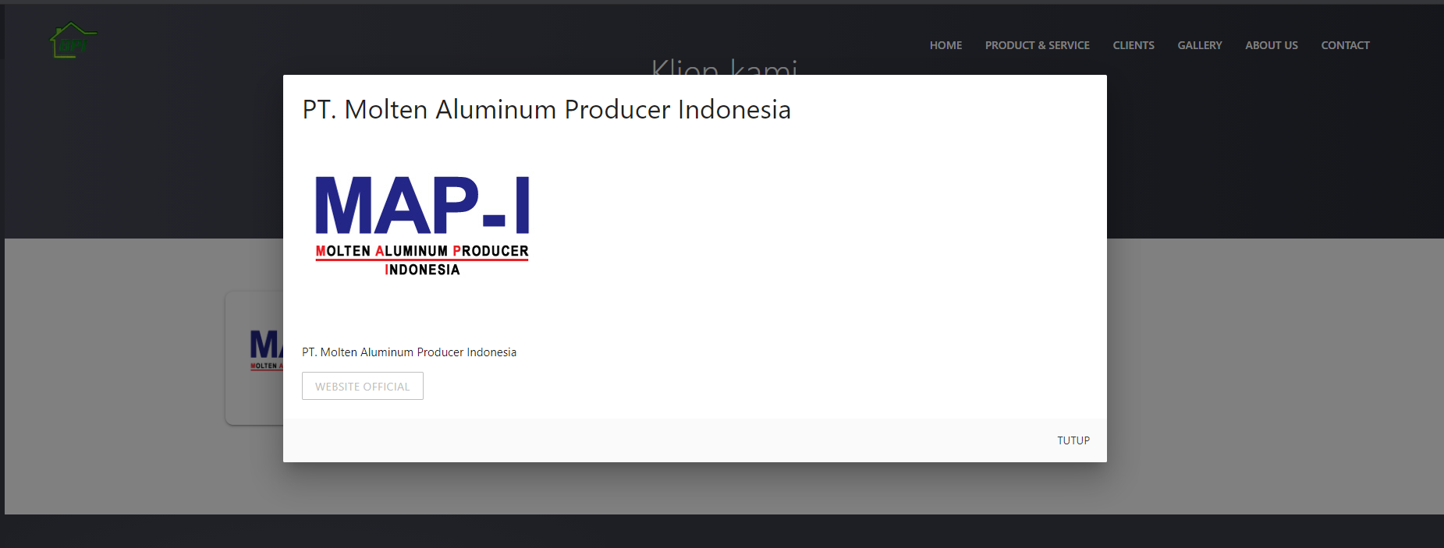

1. Gallery

Redesign halaman gallery dan penambahan detil photo Ketika di klik

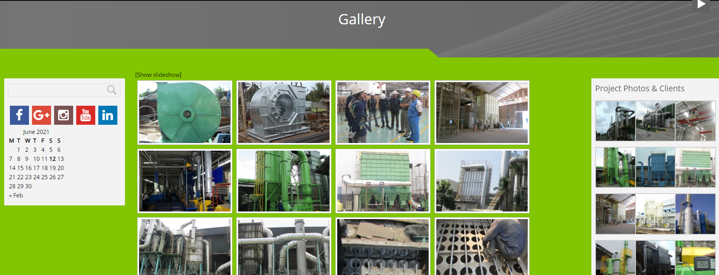

To:

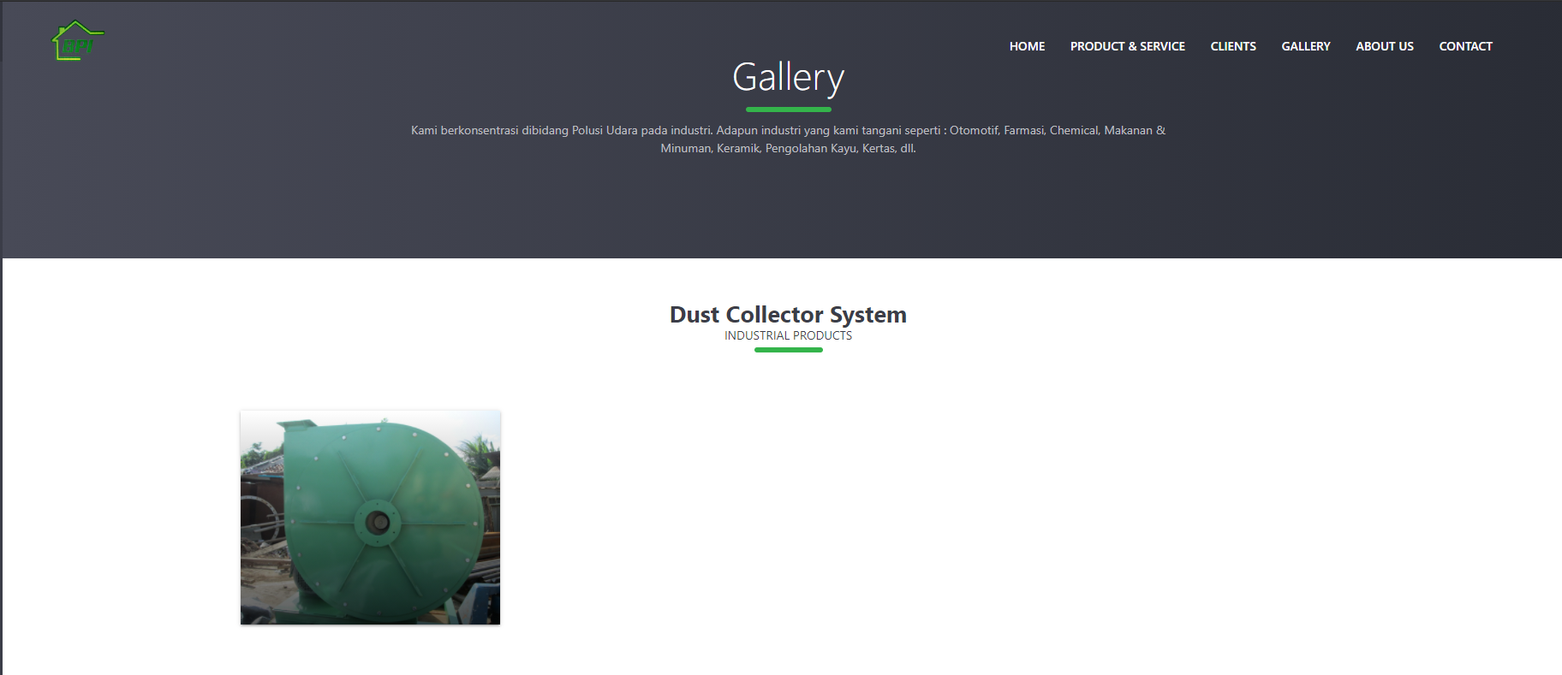

From:

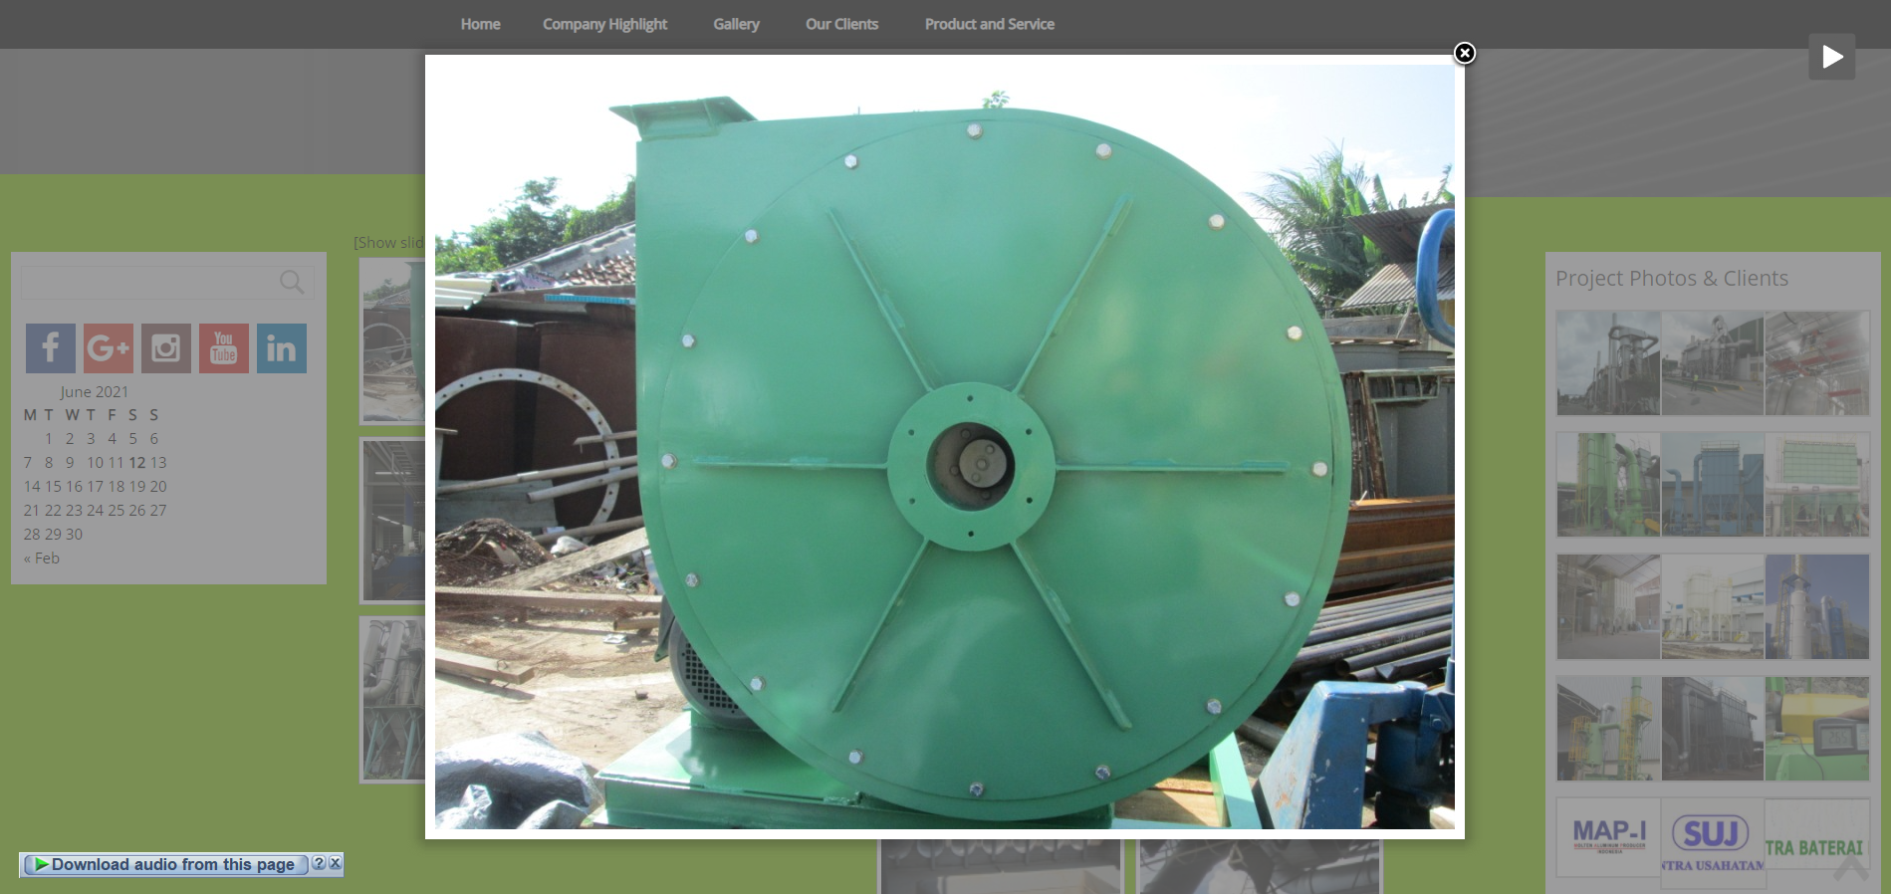

To:

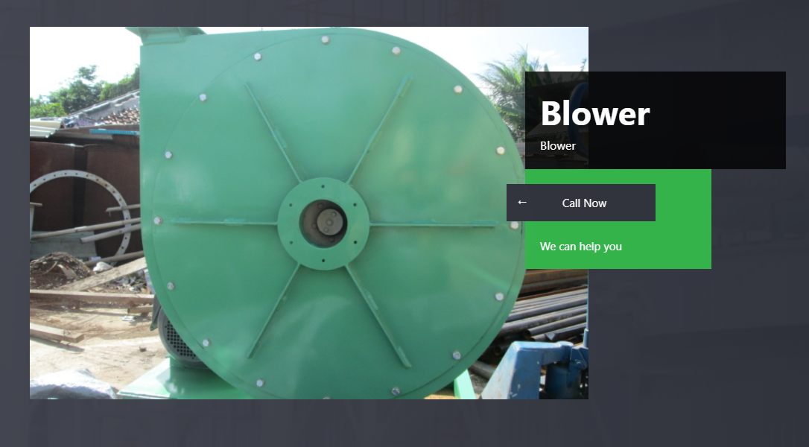

**5 Company Highlight/About us**

From

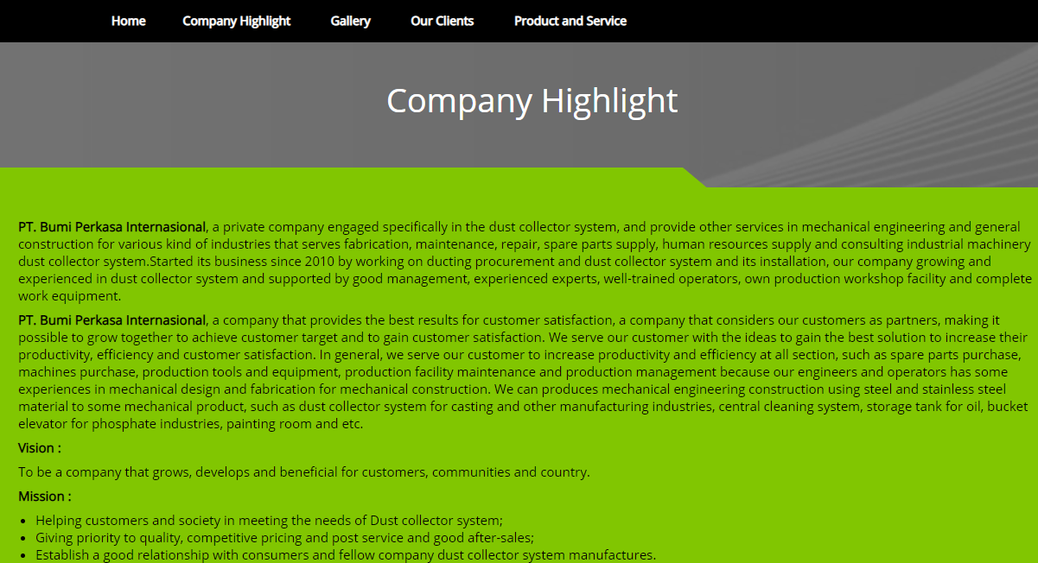

To:

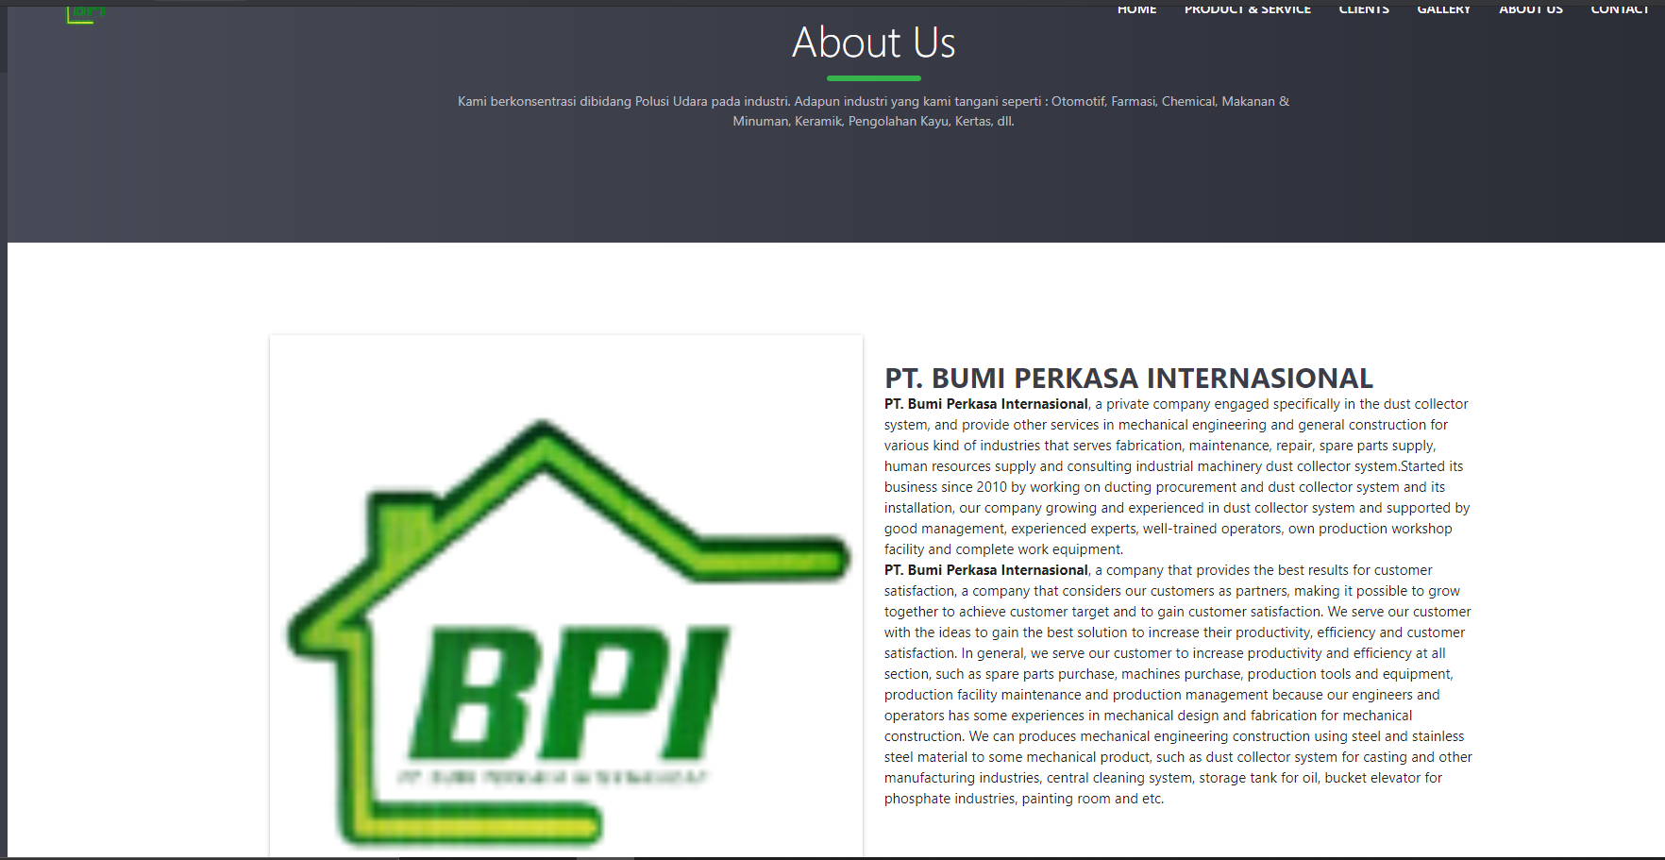**6 Contact us / hubungi kami**

Penambahan screen contact us terpisah

